This is an architecture for an industrial plant that collects data from machines, sensors, documents, and business systems, then brings it all into one place so it can be analyzed and monitored.

Data Flow
The company's existing business database gets copied into Amazon Aurora, which is basically AWS's managed version of a relational database like MySQL or PostgreSQL. Think of it as: same kind of database, but AWS handles the backups, scaling, and maintenance for you.
Enterprise

Overview
This architecture outlines the dataflow of a large industrial setup, where data is collected from multiple sources and in multiple formats. This includes real time IoT data from plant equipment such as the Distributed Control System and Historian, structured data from an existing enterprise database, and unstructured files such as documents and media. All of this data is brought into an AWS data lake, using Amazon S3 as the central storage layer and AWS Glue to catalogue the data so it can be understood and queried. Once catalogued, the data is made available for analytics and reporting.

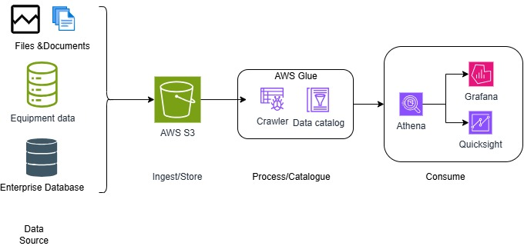

Data in this architecture arrives from multiple sources in both structured and unstructured formats, including plant equipment data, enterprise database records, and files or documents. Once this data lands in Amazon S3, AWS Glue Crawler scans it and automatically discovers its schema and structure. This information is then stored in the AWS Glue Data Catalog, which acts as a searchable index of the data's structure and location, rather than storing the data itself. With the data catalogued, Amazon Athena can run SQL queries directly against it, making the data available for analytics and reporting through tools such as QuickSight and Grafana.

Architecture diagram
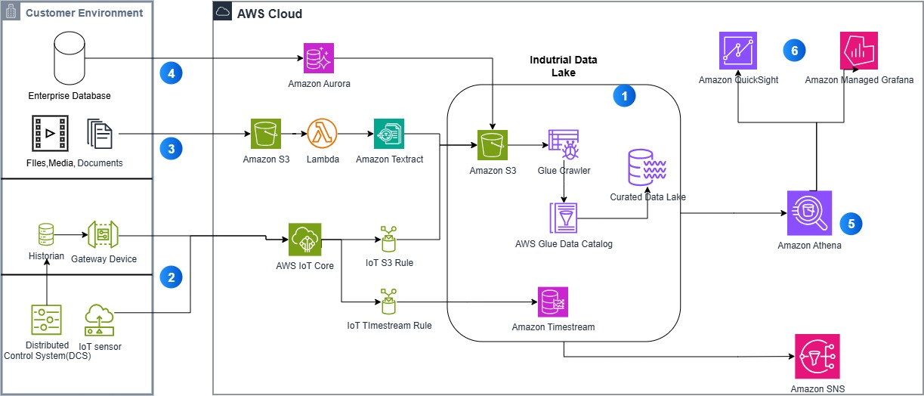
Dataflow
1. Industrial Data Lake
This is the central hub of the architecture. Data from all sources eventually lands in a landing S3 bucket. AWS Glue Crawler scans this data and discovers its schema, and this structure is stored in the AWS Glue Data Catalog. Once catalogued, the data becomes part of the Curated Data Lake, ready to be queried.
2. Machine Data (Distributed Control System, IoT Sensor, Historian)
The Distributed Control System (DCS) and IoT sensors generate real time operational data from plant equipment. This data is logged by the Historian, and passed through a Gateway Device into AWS IoT Core, which routes it into the Industrial Data Lake.
3. Files and Media
Files and media are uploaded to a separate Amazon S3 bucket, which acts as a landing zone for raw, unprocessed content. This triggers AWS Lambda, which calls Amazon Textract to extract text and structured data from the files. The extracted output is then passed into the Industrial Data Lake.
4. Enterprise Database
Structured relational data from the enterprise database is brought into Amazon Aurora, a managed relational database service, before being made available to the Industrial Data Lake.
5. Amazon Athena
Once the data is catalogued, Amazon Athena runs SQL queries directly against the Curated Data Lake, without requiring the data to be loaded into a separate database first.
6. Amazon QuickSight and Amazon Managed Grafana
The results from Athena feed two visualization tools. QuickSight is used for business style dashboards and reporting, while Grafana is used for real time operational monitoring.

Customer Environment
Distributed Control System (DCS)
Industrial equipment used to automate and control physical processes such as temperature, pressure, and flow within a plant environment.
IoT Sensor
A physical device attached to equipment that captures operational readings such as vibration, temperature, or pressure.
Historian
A specialized database designed to log and store time based operational data from industrial equipment.
Gateway Device
Hardware that connects on site equipment and sensors to cloud services, enabling data to be transmitted securely.
Enterprise Database
An existing on premises or business database used to store structured company data prior to being brought into the cloud.
AWS Cloud
AWS IoT Core
A managed service that allows connected devices to securely interact with cloud applications, acting as the entry point for IoT data into AWS.
Amazon S3
A scalable cloud storage service used to store data of any type and size. In this architecture, it serves as both a landing zone for raw files and the central storage layer for the Industrial Data Lake.
AWS Lambda
A compute service that runs code automatically in response to an event, without requiring a server to be provisioned or run continuously.
Amazon Textract
A machine learning service that extracts text, forms, and structured data from documents and scanned images.
Amazon Aurora
A managed relational database service, compatible with MySQL and PostgreSQL, used to store structured business data.
Amazon Timestream
A purpose built database service designed for storing and analyzing time series data at scale.
AWS Glue Crawler
A tool that scans data in a storage location and automatically identifies and records its schema and structure.
AWS Glue Data Catalog
A centralized metadata repository that stores information about the structure and location of data, without storing the data itself.
Curated Data Lake
The cleaned and catalogued layer of the data lake, made ready for querying and analysis.
Amazon Athena
An interactive query service that allows SQL queries to be run directly against data stored in Amazon S3, without needing to load the data into a separate database.
Amazon QuickSight
A business intelligence service used to build interactive dashboards and reports from data.
Amazon Managed Grafana
A managed service for real time monitoring and visualization, commonly used to track live operational metrics.
Amazon SNS
A fully managed notification service used to send alerts or messages when specific conditions are met.

Service Alternatives within this Architecture
Document Processing
Instead of AWS Lambda and Amazon Textract, organizations may use Amazon Comprehend for natural language processing needs, or build a custom OCR pipeline on Amazon EC2. The decision depends on whether the requirement is limited to text and form extraction, or whether more customized document understanding is needed.
Enterprise Database
Instead of Amazon Aurora, organizations may use Amazon RDS if Aurora's additional performance and scaling capabilities are not required, or Amazon DynamoDB if the enterprise data is better suited to a NoSQL structure rather than a relational one.
IoT Data Ingestion
Instead of AWS IoT Core alone, organizations with a need for local processing before data reaches the cloud may use AWS IoT Greengrass, which allows data to be filtered or processed directly on the gateway device.
Time Series Storage
Instead of Amazon Timestream, organizations may use Amazon RDS or a self-managed time series database such as InfluxDB on Amazon EC2, particularly if the team already has expertise with a specific tool outside AWS-managed services.
Data Cataloguing
Instead of AWS Glue Crawler and Data Catalog, organizations with a fixed and well understood data structure may define schemas manually, or use an alternative metadata store such as Apache Hive Metastore. Automatic schema discovery is most valuable when data structure varies or changes over time.
Query Layer
Instead of Amazon Athena, organizations with high query volume or complex analytical workloads may use Amazon Redshift Spectrum or Amazon EMR with Presto, both of which offer provisioned compute for more demanding querying needs.
Business Intelligence and Visualization
Instead of Amazon QuickSight, organizations that have already standardized on a different business intelligence tool may continue using Tableau or Power BI, alongside Grafana for real time operational monitoring.

